MyBatis Generator快速开始引导

**MyBatis Generator Quick Start Guide**

# 快速开始引导步骤：

## 创建和填充配置文件；

## 保存配置文件；

## 告诉MBG使用该配置文件；

## 创建或修改MyBatis的标准配置文件。

# MyBatis Generator Quick Start Guide

To get up and running quickly with **MyBatis Generator (MBG)**, follow these steps:

## 配置文件：Create and fill out a configuration file appropriately.

At a minimum, you must specify:

### A <jdbcConnection> element to specify how to connect to the target database

### A <javaModelGenerator> element to specify target package and target project for generated Java model objects

### A <sqlMapGenerator> element to specify target package and target project for generated SQL map files

### (Optionally) A <javaClientGenerator> element to specify target package and target project for generated client interfaces and classes (you may omit the<javaClientGenerator> element if you don't wish to generate Java client code)

### At least one database <table> element

See the [XML Configuration File Reference](http://www.mybatis.org/generator/configreference/xmlconfig.html) page for an example of a configuration file.

<http://www.mybatis.org/generator/configreference/xmlconfig.html>

## 保存配置文件：

Save the file **in some convenient location** (like \temp\generatorConfig.xml)

## Run MBG from the command line with a command like this:

**java -jar** mybatis-generator-core-x.x.x.jar **-configfile** \temp\generatorConfig.xml **–overwrite**

作用：告诉MBG使用该配置文件，参数-overwrite会覆盖原来重名的配置文件。

**This will tell MBG to run using your configuration file**. It will also tell MBG to overwrite any existing Java files with the same name. If you want to save any existing Java files, then omit(忽略) the -overwrite parameter. If there is a conflict, MBG will save the newly generated file with a unique name (e.g. MyClass.java.1).

## create or modify the standard MyBatis or iBATIS configuration files

After running MBG, you will need **to create or modify the standard MyBatis or iBATIS configuration files** **to make use of your newly generated code.** See the [Tasks After Running MyBatis Generator](http://www.mybatis.org/generator/afterRunning.html) page for more information.

<http://www.mybatis.org/generator/afterRunning.html>

**Important:** Generated code for iBATIS2 requires that statement **namespaces** are enabled in your iBATIS configuration. See the [Tasks After Running MyBatis Generator](http://www.mybatis.org/generator/afterRunning.html) page for more information.

# Running MyBatis Generator：运行MBG

MyBatis Generator (MBG) can be run in the following ways:

### From the command prompt with an XML configuration

### As an Ant task with an XML configuration

### As a Maven Plugin(插件)

### From another Java program with an XML configuration

### From another Java program with a Java based configuration

### As an Eclipse Feature

**Note:** there is also an Eclipse plugin for MBG that adds extra function - namely good integration into Eclipse, an Eclipse enabled Ant task, and support for automatic merging of Java files. See the [MyBatis](http://mybatis.org/) web site page for information on installing the Eclipse plugin.

## Running MyBatis Generator from the Command Line

You must create an XML configuration file to run MBG from the command line. If the file is named "generatorConfig.xml", then any of the following command lines will run MBG:

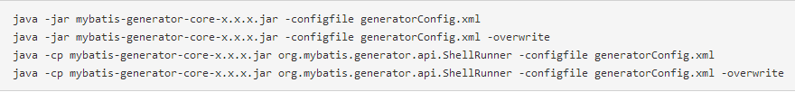

## Running MyBatis Generator With Ant

## Running MyBatis Generator With Maven

MyBatis Generator (MBG) includes a Maven plugin for integration into a maven build. In keeping with Maven's configuration by convention strategy, including MBG in a Maven build can be very simple. The minimum configuration is shown below:

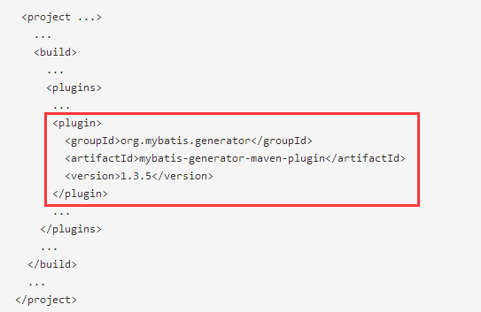

<plugin>

<groupId>org.mybatis.generator</groupId>

<artifactId>mybatis-generator-maven-plugin</artifactId>

<version>1.3.5</version>

</plugin>

<http://www.mybatis.org/generator/running/runningWithMaven.html>

# Tasks After Running MyBatis Generator

After you run MyBatis Generator (MBG), you will need **to create or modify other MyBatis or iBATIS configuration artifacts**. The main tasks are as follows:

## For MyBatis 3.x:

Create or Modify **the MapperConfig.xml** file

## For iBATIS 2.x:

Create or Modify the **SqlMapConfig.xml** file

Create or modify the **dao.xml** file (only if using **the iBATIS DAO Framework**)

Each task is described in detail below.

## Updating the MapperConfig.xml File (MyBatis 3.x)

**MyBatis 3.x** uses an XML file, commonly named **MapperConfig.xml**, to specify information **for a database connection**, **a transaction management scheme**, and **XML mapper files** that will be used in a MyBatis session. MBG cannot create this file for you because it knows nothing about your execution environment. However, some of the items in this file relate directly to **MBG generated items**. Please refer to the standard MyBatis data mapper developer guide for details about the different configuration options.

**MBG specific needs** in the configuration file are as follows:

**MBG generated XML mapper files** must be listed

For example, suppose that MBG has generated an XML mapper file called **MyTableMapper.xml**, and that the file has been placed in the **test.xml package** of your project. The **MapperConfig.xml** file should have these entries:

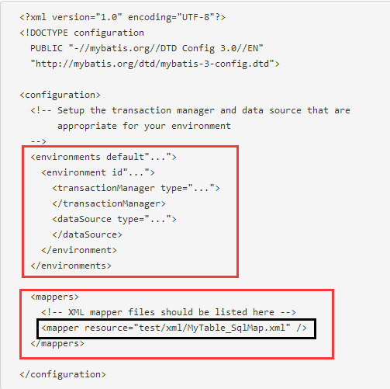

If there is more than one XML mapper file (as is quite common), then the files can be listed **in any order** **with repeated <mapper> elements** after the <mappers> element.

**Generated MapperConfig.xml** You may ask MBG to generate a skeleton(骨架) Mapper Configuration file with the MapperConfigPlugin. See the <plugin> page for more information.

## Updating the SqlMapConfig.xml File (iBATIS 2.x)

略，见官网介绍：<http://www.mybatis.org/generator/afterRunning.html>